Circuit Design Assignment 2: Simulation and Breadboarding

Assignment due Monday at 11:59pm EST

# **1 Objectives**

* Gain familiarity with common components found in electrical engineering
* Build confidence in designing and building a physical circuit, and how to debug a non-functioning circuit since that’s probably the *most* useful skill to have in your electrical toolbox
* Learn to use a multimeter to assist in the building and debugging of a circuit
* Reinforce concepts from lecture, such as how to read a datasheet and how to simulate a circuit using softwares used often in the real world (LTSpice)

# **2 Parts**

* Breadboard
* Wires
* Wire strippers
* Power Cord
* Assorted Resistors
* Assorted Capacitors
* Multimeter
* Operational Amplifier
* Inverter
* AND Gate
* OR Gate

# **3 Pre-Lab**

# 3.1: Digital Logic

## 3.1.1: Truth Tables

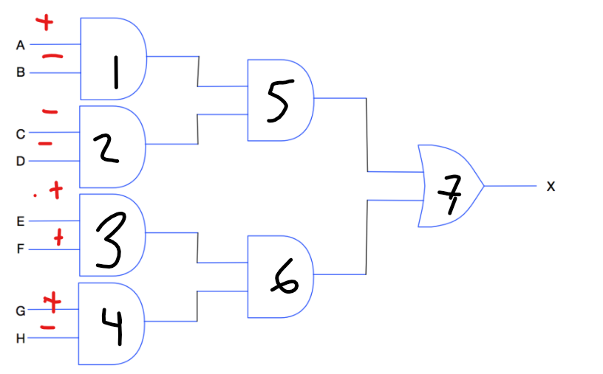

**What is the output of the above circuit? 0 V / -**

**What if pin H had an inverter on it? 5 V / +**

**What if pin C had an inverter on it? 0 V / -**

**What is the truth table for the A-D part of the associated circuit? (Ignoring the drawn +/- markings) Ie, what is the truth table at the output of element number 5. Feel free to use Excel, pen an paper, or write it using a chart directly in Google Docs as you see fit.**

## 3.1.2: Datasheet Comprehension

Find the datasheets for your INV, AND, and NOR gate chips. Use google and/or digikey.com. Their part numbers are listed in the chart below. Further, determine for each one of them the associated voltage it needs to be supplied, maximum current, voltage at the output, and voltage needed to enable a ‘high’ signal:

|  | Part Number | Voltage Supply | Maximum Current | Voltage Enable | Voltage Output |
| --- | --- | --- | --- | --- | --- |
| AND | TC74HC08APF | 2V ~ 6V | 1 uA | 0 to Vcc | 0 to Vcc |
| OR | SN74HC32N | 2V ~ 5V ~ 6V | 2 uA | 0 to Vcc | 0 to Vcc |
| INV | SN74AHC14N | 2V ~ 5V | 2 uA | 0 to 5.5V | 0 to Vcc |

**What should your input voltage be?** 3.3 V

(Note your board can only supply 5V or 3.3V, unless you want to use a resistor divider or opamp circuit to generate a lower voltage input.. Which you’re definitely free to do for an extra challenge!)

## 3.1.3: Design your Schematic

Now that you know how these schematics work, design a circuit that uses at least one AND and OR gate, and an inverter (you may use additional circuits if needed/desired). This circuit must be on if and only the third and fourth pin is enabled by a push button. Otherwise, other pins may be pulled down (grounded)... or you can pull them high (power) or use other buttons for an extra challenge. Additionally, add an LED and a resistor on your output (review Assignment 1 for the resistor sizing equation, and the expected voltage you just put into the chart above!) The push button can look like a switch in your schematic since it operates like a switch.

**What does this circuit look like?**

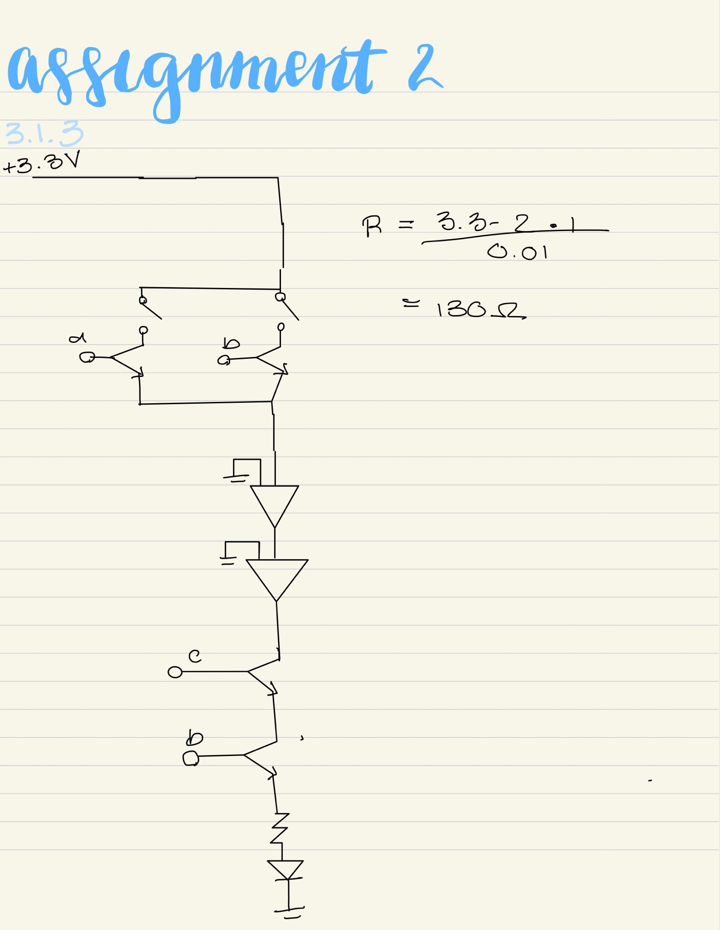

## 3.1.4: Verify your Schematic in LTSpice

Now try this circuit out on LTSpice to make sure it performs as expected. Please use generic AND/OR/INV parts. Include both a **screenshot of the program schematic, as well as the output plot.** There are additionally fantastic youtube videos on running LTSpice simulations so feel free to check those out if you’re having trouble getting started!

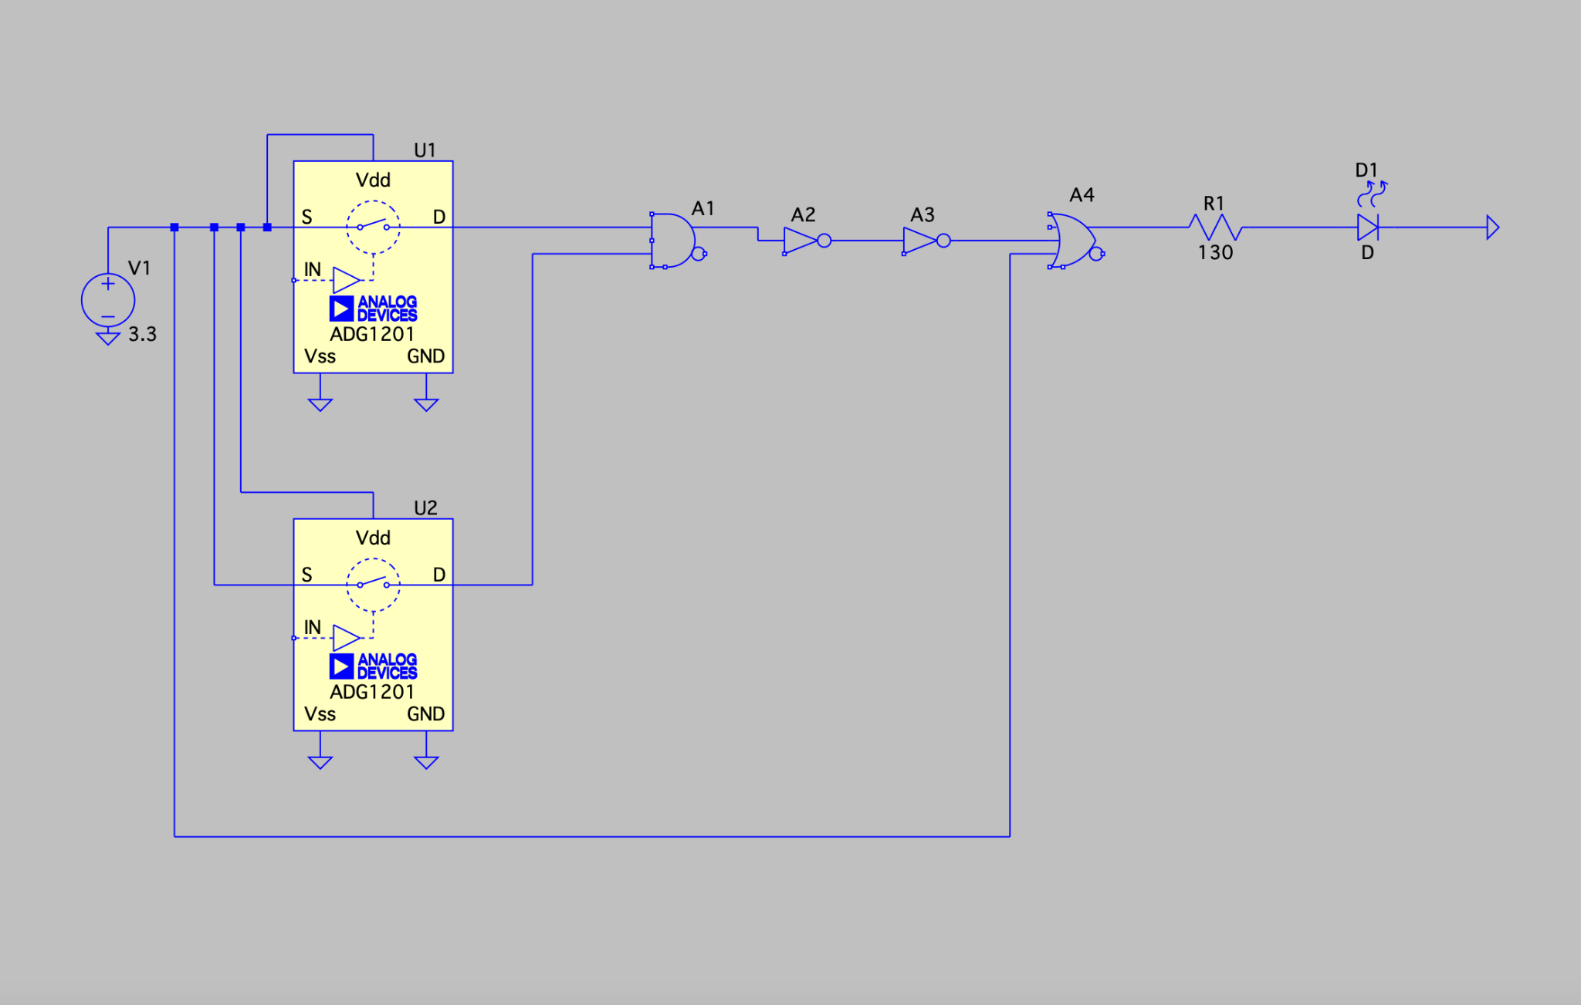

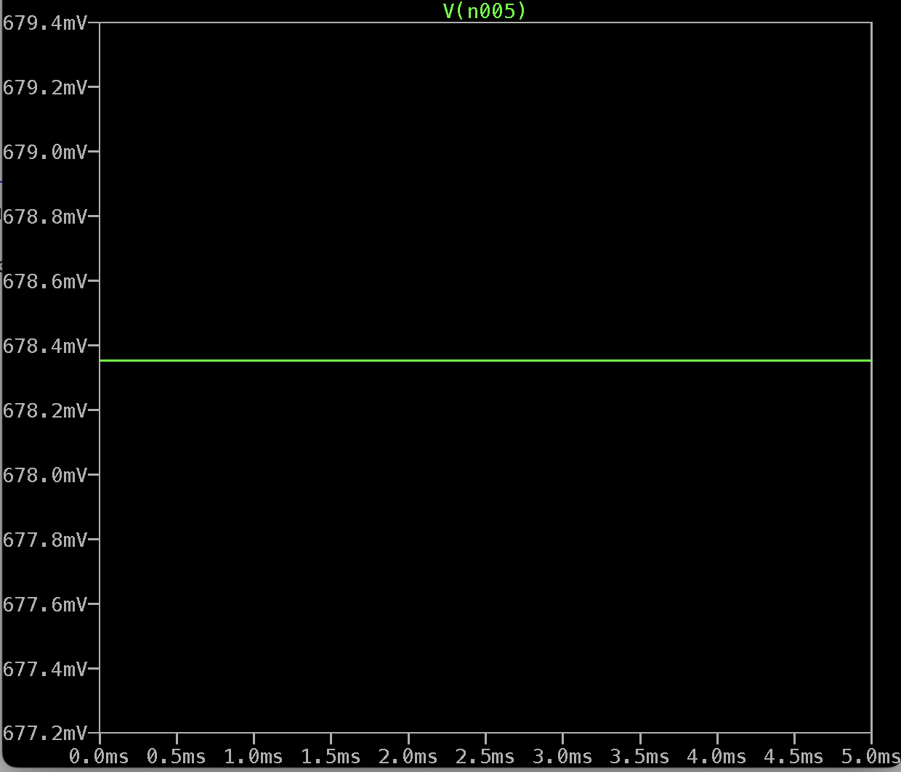

# **4 Lab**

# 4.1: Getting Setup

## 4.1.1: Identify Part Pinouts

Now it’s time to turn a theoretical schematic into actual parts. The most important first step is to find the pinout for a part to make sure you know what is an input, output, power, or ground. Fortunately, the datasheet tells you this. For your convenience, here’s a complete list of the pinouts of each of the parts you’ll need in this assignment.

INVERTER Gate

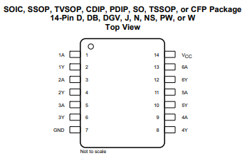

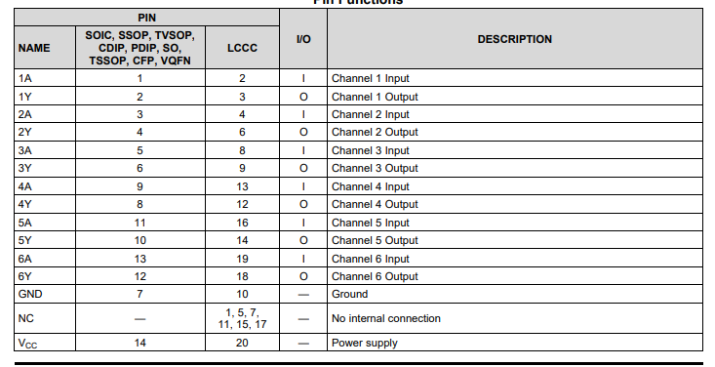

OR Gate:

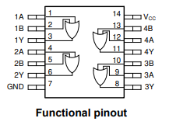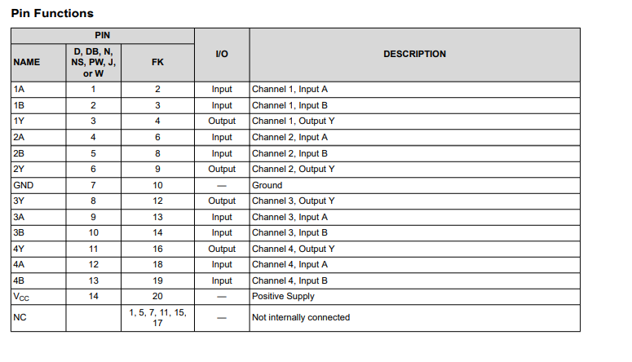

AND Gate:

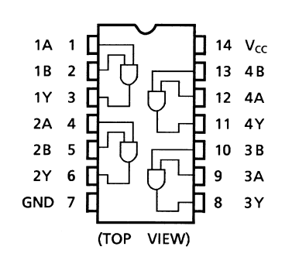

Note that, for each part, pin 1 is the pin on the left hand side of the notch you’ll see in your IC (so, if the chip is oriented like in the photo the pins and the diagram numbering should line up to be exactly the same).

Additionally, your LED is also directional. The longer pin is known as the anode and the shorter pin is the cathode and should be connected to ground.

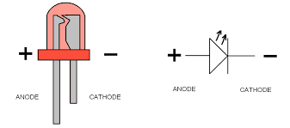

Push button

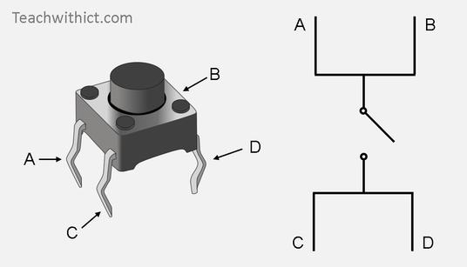 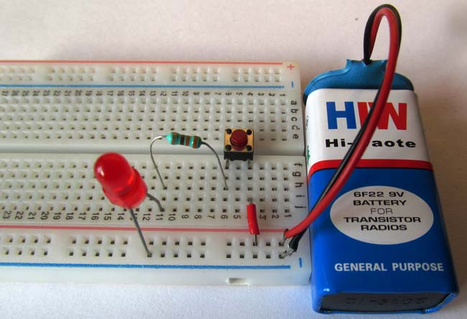

Make sure that you are supplying power to the input (pin A). The circuit on the right is for reference only

There is nothing to submit for this part of the assignment, it’s purely for reference.

## 4.1.2: Setup Power Converter

Identify your power converter, it should look like this:

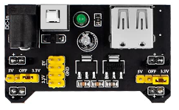

Attach it to your laptop power by connecting the USB to barrel jack connector between your board and your laptop. Attach it directly on top of your breadboard with the +/-’s of the converter lining up with the +/-’s of the breadboard.

Using your multimeter measure the power out of the rails. **Measure the output of the voltage rail on the left and measure the output of the voltage rail on the right. What are those voltages? 3.32 V**

For reference, here’s how you can measure multimeter voltage:

* Plug one black multimeter cable into the black hole on the multimeter and the matching red cable into the red hole on the multimeter.
* Turn the dial on the multimeter to the V setting with a bar above it (should say mV).
* Attach a wire out of the positive rail (the column of holes under the red plus sign), do this for both the left and right rails since they may have different voltages. You may change these voltages by moving the yellow connectors on your power device
* Attach a wire out of the negative rail (the column of holes under the blue negative sign)
* Measure the voltage by touching the red multimeter cable to your power wire and the black multimeter cable to your ground wire

# 

# 4.2: Digital Logic

## 4.2.1: Build your circuit!

Time to build your circuit! For reference, each of the parts that live in your kits are labeled as followed:

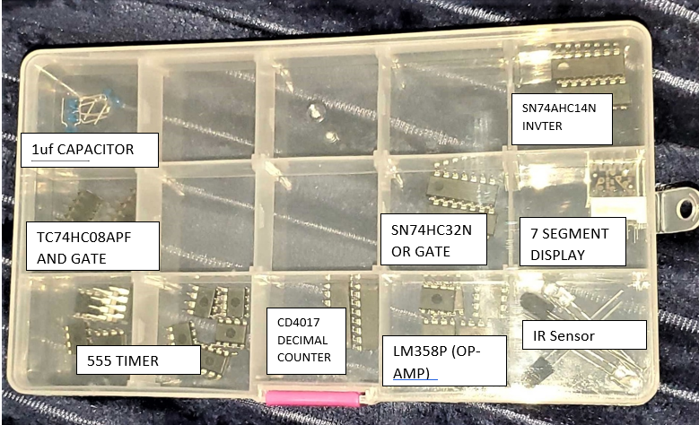

Once again, follow your schematic from part 3.1.3 and the pinouts from part 4.1.1

**Attach a photo of your test setup/breadboard.**

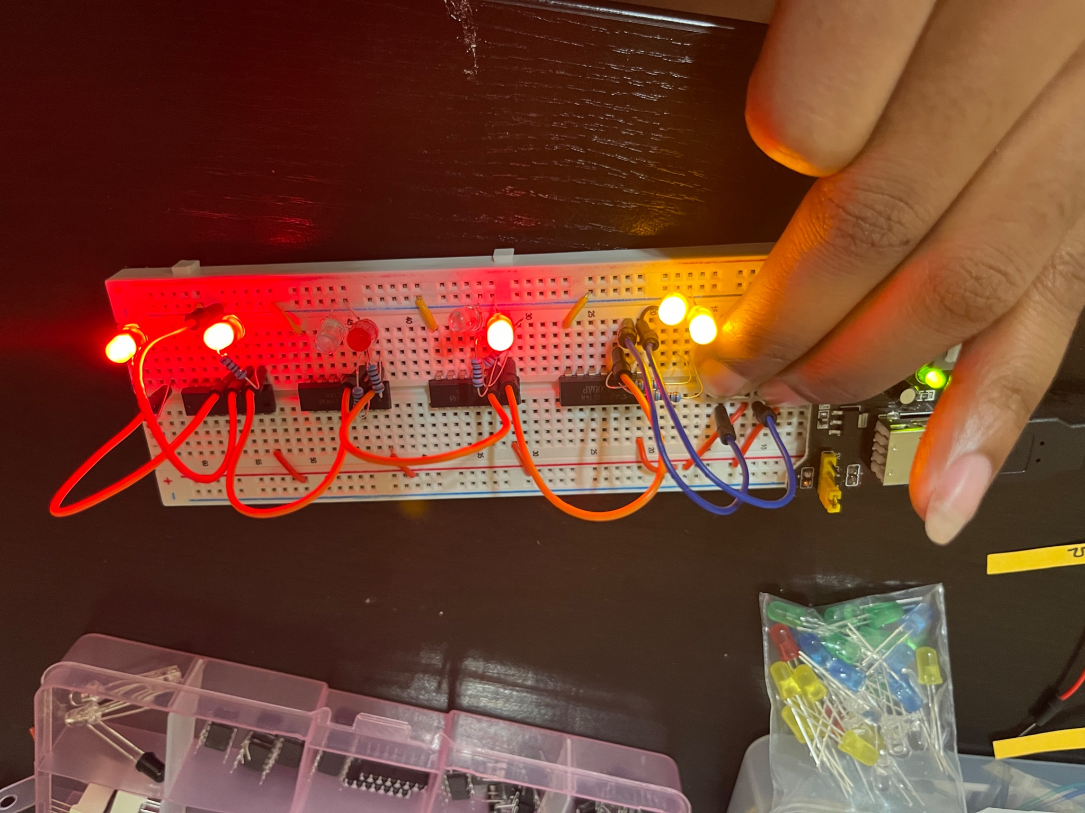

A reminder of some good breaboarding practices:

* Red=power, black=gnd, other colors= other lines (not a hard and fast rule, but is generally best practice)
* When you’re sure of a placement strip a wire to size and use that to make your circuit easier to follow
* Keep your circuit unplugged from laptop power except when powering something actively. DOUBLE CHECK EVERYTHING IS GROUNDED BEFORE TURNING ON YOUR CIRCUIT, OTHERWISE YOUR PARTS MAY BREAK

## 

## 4.2.1: Probe the output

**Does the light turn on when the button is pressed? Provide a picture See picture above**

**What is the voltage right before the LED when you press your button?** (If this voltage is 0V then revisit part 4.2.1 and 3.1.4)

**What is the voltage right before the LED when you don’t have your button pressed?** (If this voltage is NOT 0V then revisit part 4.2.1 and 3.1.4)

If your circuit doesn’t work double check pin numbers/pinouts, voltage lines, grounding, and that the wires are pushed all of the way in. Use your multimeter to help you know when you have a positive voltage coming through, and when you don’t! Sometimes, you might even want to switch your chip out for another one in case it broke when you weren’t expecting it. Debugging circuits is a really useful skill to have, and it’s super easy to make little mistakes. If something isn’t working just push through it, you got this!

**My breadboard consistently was no showing a power output over 2.1mV. I attempted to debug my board by disassembling the whole thing and check each individual input and output of my gates and inverters. I found that all my chips were working properly. When I rewired the board I made sure that each chip was grounded and had a power input. Even after completing these steps my board would not produce a correct voltage.**

# **5 Preparing for Next Class**

# 5.1 Download the Arduino IDE

<https://www.arduino.cc/en/software>

# 5.2 Watch the following videos to acquaint yourself with programming fundamentals

If this is your first programming course:

<https://www.youtube.com/watch?v=I-k-iTUMQAY>

If this is your first time using an arduino:

<https://www.youtube.com/watch?v=BtLwoNJ6klE>

# 

# 

# 

# **6 Reflection**

Individually, answer the questions below. Two to four sentences for each question is sufficient. Answers that demonstrate little thought or effort will not receive credit!

# 5.1: What was the most valuable thing you learned, and why?

The most vaulabe thing I learned was to use LED light bulbs to show the inout and out puts into gates. This was a very valuable lesson because it made the assignment less confusing because I was able to pinpoint what exactly I did wrong.

5.2: What skills or concepts are you still struggling with? What will you do to learn or practice these concepts?

My biggest struggle was definitely figuring out the preliminary schematics because I wasn’t sure what all need to be grounded and have a voltage. I learned alot about this concept through breadboard building, so I have a much better understanding.